CPE301 – FALL 2019

Design Assignment 5

Student Name: Henry Mesa

Student #: 1008099273

Student Email: mesah1@unlv.nevada.edu

Primary Github address: https://github.com/mesah1

Directory: https://github.com/mesah1/submissions

1. **COMPONENTS LIST AND CONNECTION BLOCK DIAGRAM w/ PINS**

List of Components used :

Atmega328PB

NRF24L01

LM35

Multi-Function Shield

Block diagram with pins used in the Atmega328PB:

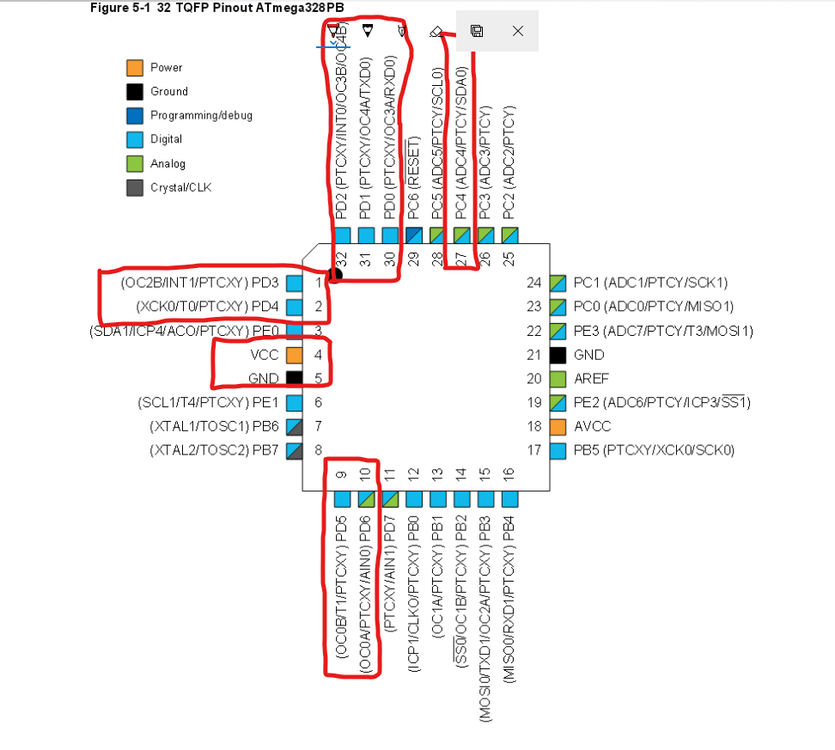

1. **INITIAL/MODIFIED/DEVELOPED CODE OF TASK 1/A**

/*

* DA5.c

*

* Created: 12/3/2019 6:04:07 PM

* Author : Henry Mesa

*/

// Set clock frequency

#ifndef *F_CPU*

#define *F_CPU* 16000000UL

#endif

#include <avr/io.h>

#include <util/delay.h>

#include <avr/interrupt.h>

#include <stdbool.h>

#include <stdio.h>

#include <string.h>

// Set up UART for printf();

#define UBRR_9600 103

#include "STDIO_UART.h"

// Include nRF24L01+ library

#include "nrf24l01.h"

#include "nrf24l01-mnemonics.h"

#include "spi.h"

void print_config(void);

// Used in IRQ ISR

volatile bool message_received = false;

volatile bool status = false;

void read_adc(void);

void adc_init(void);

void USART_init( );

void USART_tx_string(char *data);

volatile float adc;

char ar[20];

*uint8_t* rx_address[5] = {0x44,0x44,0x44,0x44,0x44}; //receiver address

*uint8_t* rx_address[5] = {0x72,0x72,0x72,0x72,0x72}; //transmit address

#define READ_PIPE;

int main(void)

{

adc_init(); //intialize ADC

USART_init(UBRR_9600); //initialize USART

USART_tx_string("Hello there!\n");

*_delay_ms*(500);

// Set cliche message to send (message cannot exceed 32 characters)

char tx_message[32]; // Define string array

*strcpy*(tx_message,"Hello World!"); // Copy string into array

// Initialize UART

USART_init();

// Initialize nRF24L01+ and print configuration info

nrf24_init();

print_config();

// Start listening to incoming messages

nrf24_start_listening();

while (1)

{

if (message_received)

{

// Message received, print it

message_received = false;

*printf*("Received Temperature: %s\n",nrf24_read_message());

// Send message as response

*_delay_ms*(500);

status = nrf24_send_message(tx_message);

if (status == true) *printf*("Transmitted Temperature");

}

read_adc();

*snprintf*(ar, sizeof(ar),"%f\r\n",adc); //print

USART_tx_string(ar);

*_delay_ms*(1000); //wait 1s

}

}

// Interrupt on IRQ pin

ISR(INT0_vect)

{

message_received = true;

}

void print_config(void)

{

*uint8_t* data;

*printf*("Startup successful\n\n nRF24L01+ configured as:\n");

*printf*("-------------------------------------------\n");

nrf24_read(CONFIG,&data,1);

*printf*("CONFIG 0x%x\n",data);

nrf24_read(EN_AA,&data,1);

*printf*("EN_AA 0x%x\n",data);

nrf24_read(EN_RXADDR,&data,1);

*printf*("EN_RXADDR 0x%x\n",data);

nrf24_read(SETUP_RETR,&data,1);

*printf*("SETUP_RETR 0x%x\n",data);

nrf24_read(RF_CH,&data,1);

*printf*("RF_CH 0x%x\n",data);

nrf24_read(RF_SETUP,&data,1);

*printf*("RF_SETUP 0x%x\n",data);

nrf24_read(STATUS,&data,1);

*printf*("STATUS 0x%x\n",data);

nrf24_read(FEATURE,&data,1);

*printf*("FEATURE 0x%x\n",data);

*printf*("-------------------------------------------\n\n");

}

/* INITIALIZING ADC */

void adc_init(void){

//ADC ENABLE AND SET-UP

ADMUX = (0 << REFS1)| // external cap at AREF

(1 << REFS0)| // AVcc - Reference Selection INTERNAL

(0 << ADLAR)| // ADC Left Adjust Result

(1 << MUX2)| // Analog Channel Selection Bits

(0 << MUX1)| // ADC4 (PC4)

(0 << MUX0);

ADCSRA = (1 << ADEN)| // ADC ENable

(0 << ADSC)| // ADC Start Conversion

(0 << ADATE)| // ADC Auto Trigger Enable

(0 << ADIF)| // ADC Interrupt Flag

(0 << ADIE)| // ADC Interrupt Enable

(1 << ADPS2)| // ADC Prescaler Select Bits

(0 << ADPS1)|

(1 << ADPS0);

}

/* READ ADC PINS */

void read_adc(void){

unsigned char i = 4;

adc = 0;

while (i--)

{

ADCSRA |= (1 << ADSC);

while(ADCSRA & (1 << ADSC));

adc+= ADC;

*_delay_ms*(50);

}

adc = adc / 4; // Average a few samples

}

/* INITIALIZING USART (RS-232) */

void USART_init(unsigned int ubrr){

UBRR0H = (unsigned char)(ubrr >> 8);

UBRR0L = (unsigned char)ubrr;

UCSR0B = (1 << TXEN0); //transmitter enabled

UCSR0C = (1 << UCSZ01) | (1 << UCSZ00); //5-bit characters

}

/* SEND STRING TO RS-232 */

void USART_tx_string(char *data){

while ((*data != '\0')){

while (!(UCSR0A & (1 << UDRE0)));

UDR0 = *data;

data++;

}

}

1. **SCHEMATICS**

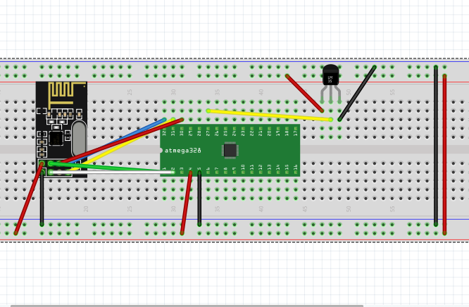

1. **SCREENSHOTS OF EACH TASK OUTPUT (ATMEL STUDIO OUTPUT)**

1. **SCREENSHOT OF EACH DEMO (BOARD SETUP)**

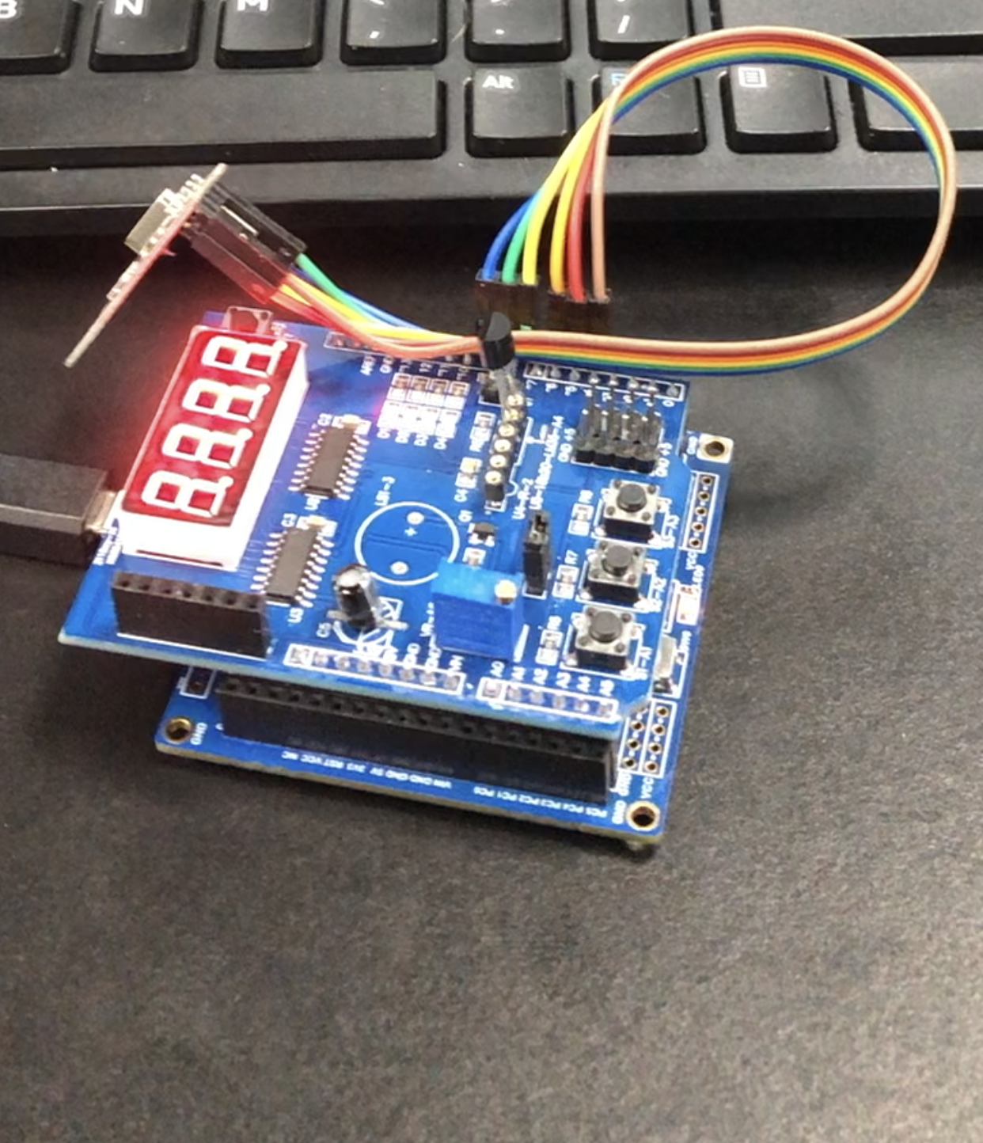

1. **VIDEO LINKS OF EACH DEMO**

<https://youtu.be/OPBZ5fp9fO4>

1. **GITHUB LINK OF THIS DA**

<https://github.com/mesah1/submissions/tree/master/DA5>

**Student Academic Misconduct Policy**

<http://studentconduct.unlv.edu/misconduct/policy.html>

“This assignment submission is my own, original work”.

Henry Mesa